LDAP Authentication in ROR

What is LDAP?

A networking protocol for accessing information directories. An LDAP directory contains data with similar attributes that is organized in a hierarchical format (example: A telephone directory or a directory of user access rights). Lightweight directory access protocol (LDAP) is a networking protocol that organizes access to data in a directory tree structure
.
An acronym for Lightweight Directory Access Protocol, which defines a standard for organizing directory hierarchies and interfacing to directory servers. A directory is a set of objects with similar attributes organized in a logical and hierarchical manner. The most common example is the telephone directory, which consists of a series of names (either of persons or organizations) organized alphabetically, with each name having an address and phone number attached. Due to this basic design (among other factors) LDAP is often used by other services for authentication.

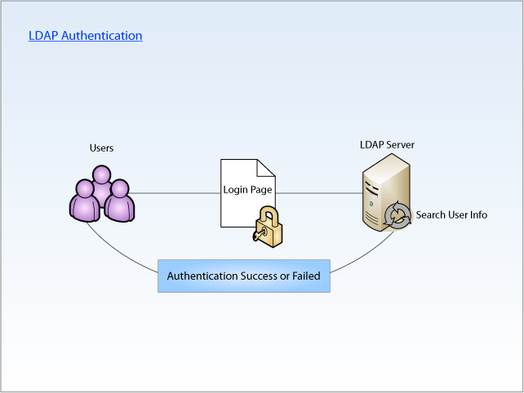

Steps to use LDAP authentication through ROR.

1.Install Gem:
gem install ruby-net-ldap.

2.Create method for LDAP authentication:

require 'net/ldap'
def authenticate(user,password)
# For checking if username and password is blank.
if user == "" || password == ""

return false

end
# For LDAP connection and sending user name and password
ldap_con = Net::LDAP.new({:host => Ldap server name,
:port => 389,:auth=>{:method=>:simple,:username => user@domainname.domain,
:password => password } } )

return true if ldap_con.bind
return false

end

- Host – LDAP sever name

- Port – By default port number 389 otherwise use the port number of your ldap server.

- Method – simple because we are just passing user name and password. We are not passing any
information for LDAP connection.

- Username – user name

- Password – user password.

- It will return true if username and password exist otherwise false.

3.Searching in LDAP server:

Make a function like this.

require 'net/ldap'
def ldap_search
ldap_con = Net::LDAP.new({:host => Ldap Server name,
:port => 389,:auth=>{:method=>:simple,:username => username@domainname.domain,
:password => password } } )

treebase = "dc=yahoo,dc=com"
filter = Net::LDAP::Filter.eq("samaccountname",params[:login][:name])
ldap_con.search(:base => treebase, :filter => filter) do |entry|
name = entry.userprincipalname
end
end

treebase: For parsing xml output as treebase.

Dc= domain name , dc= domain

samaccountname: an attribute of LDAP searching on the basis of that user can search on the basis of any other attribute.

