BLANCA ESTELA SANCHEZ RAMIREZ

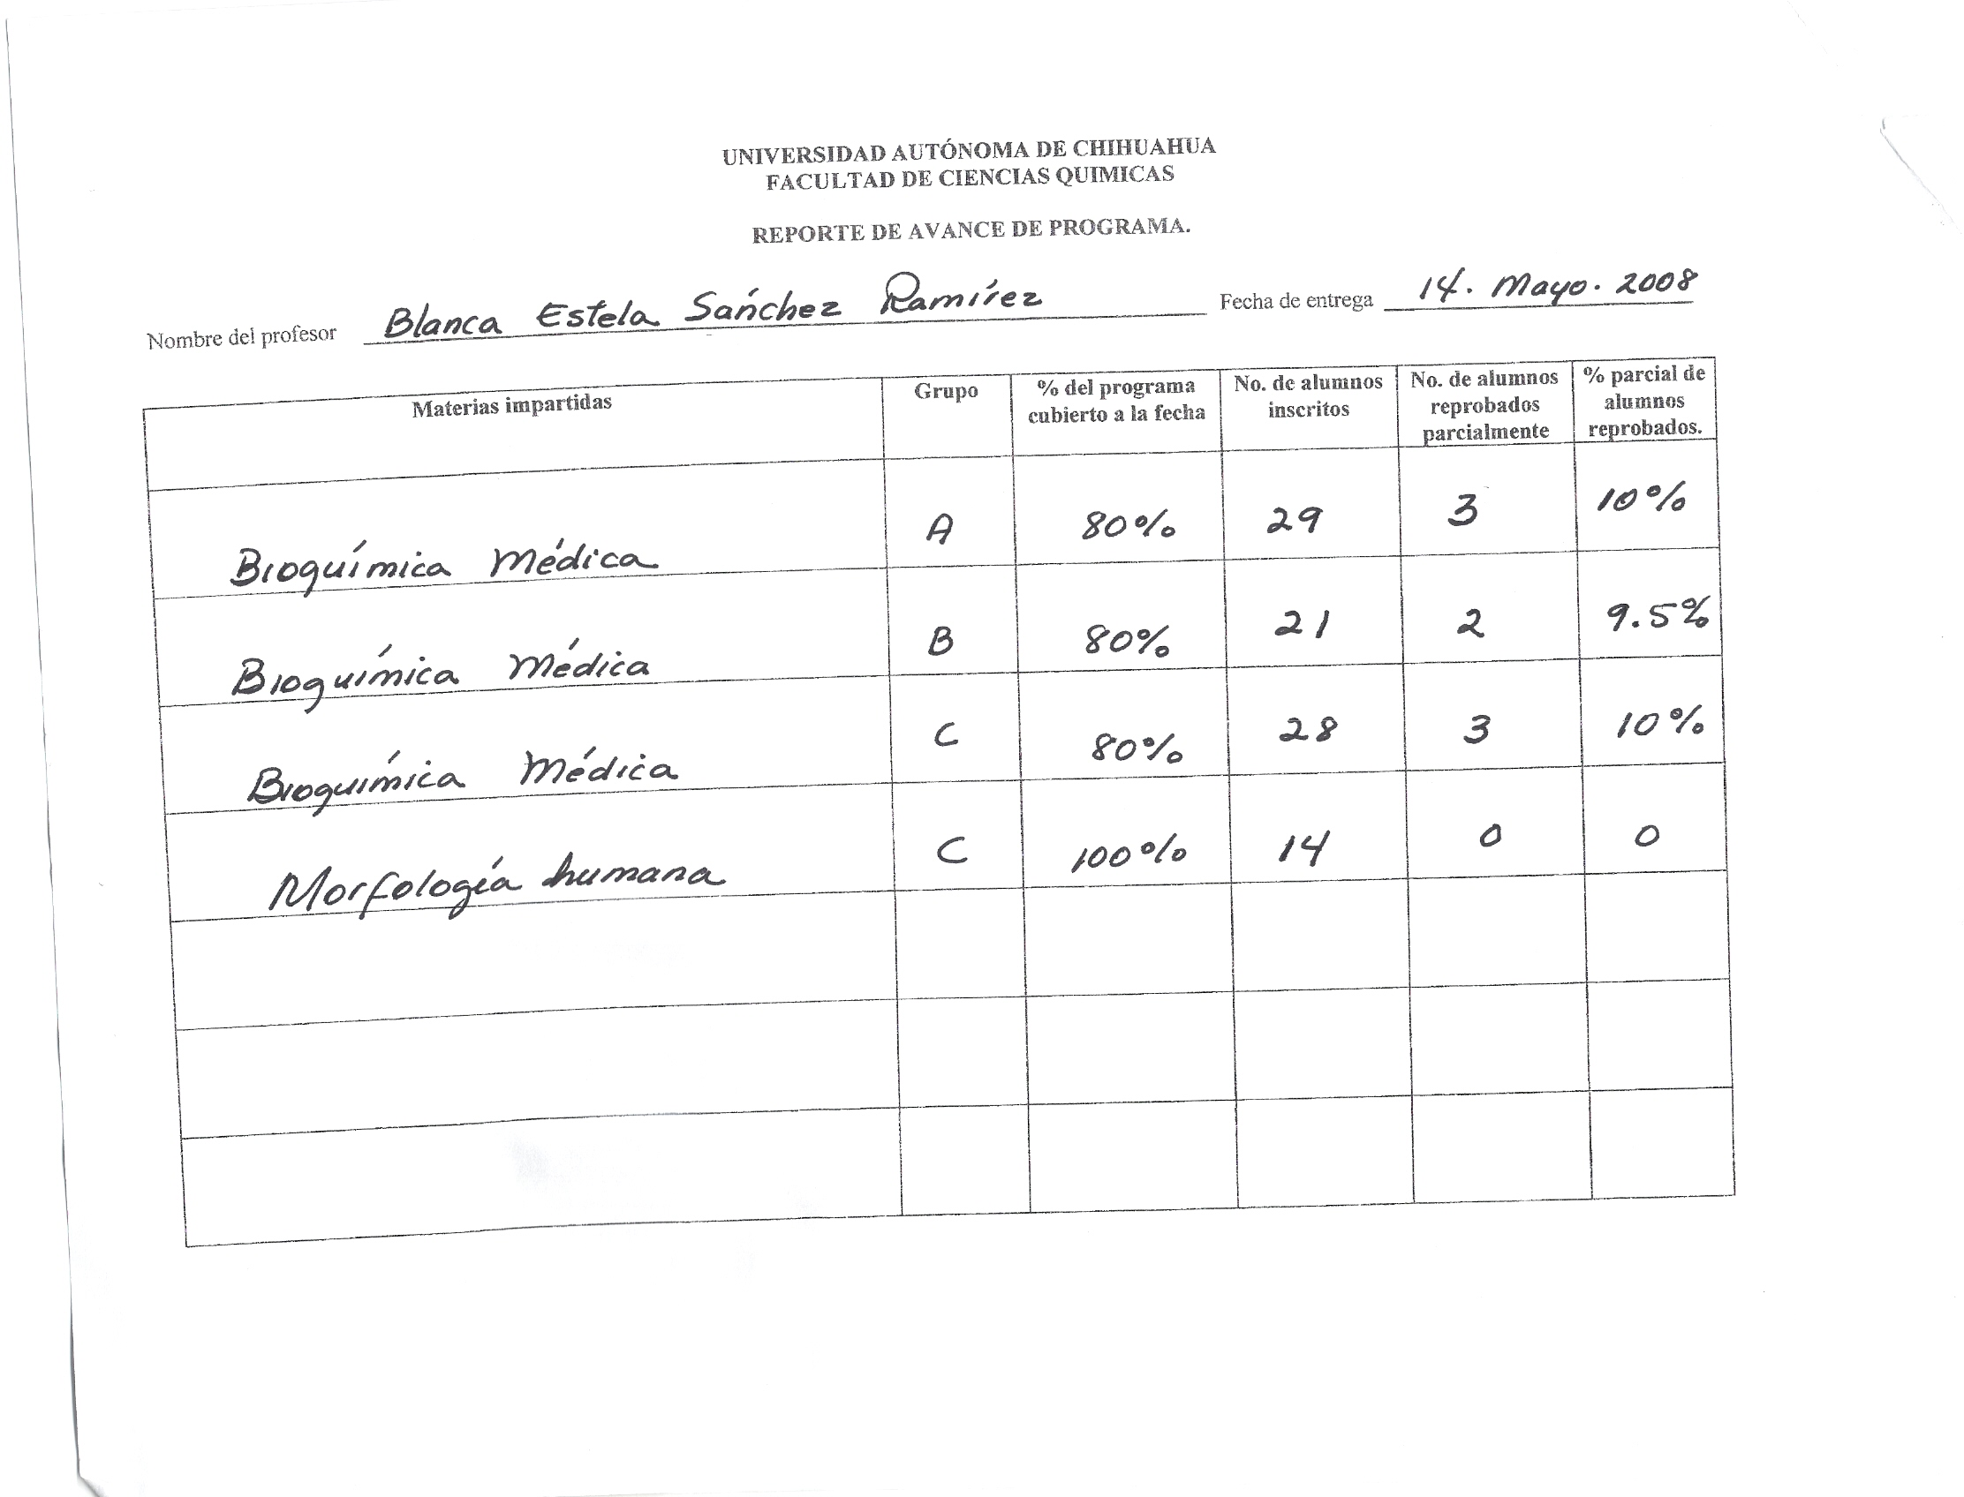

GUADALUPE VIRGINIA NEVAREZ MOORILLON
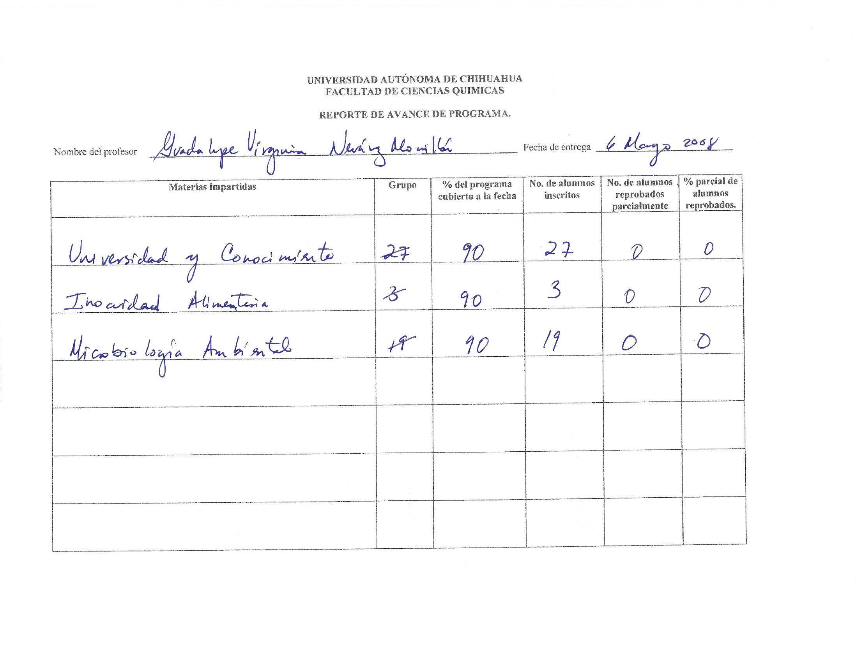

QUINTIN RASCON CRUZ

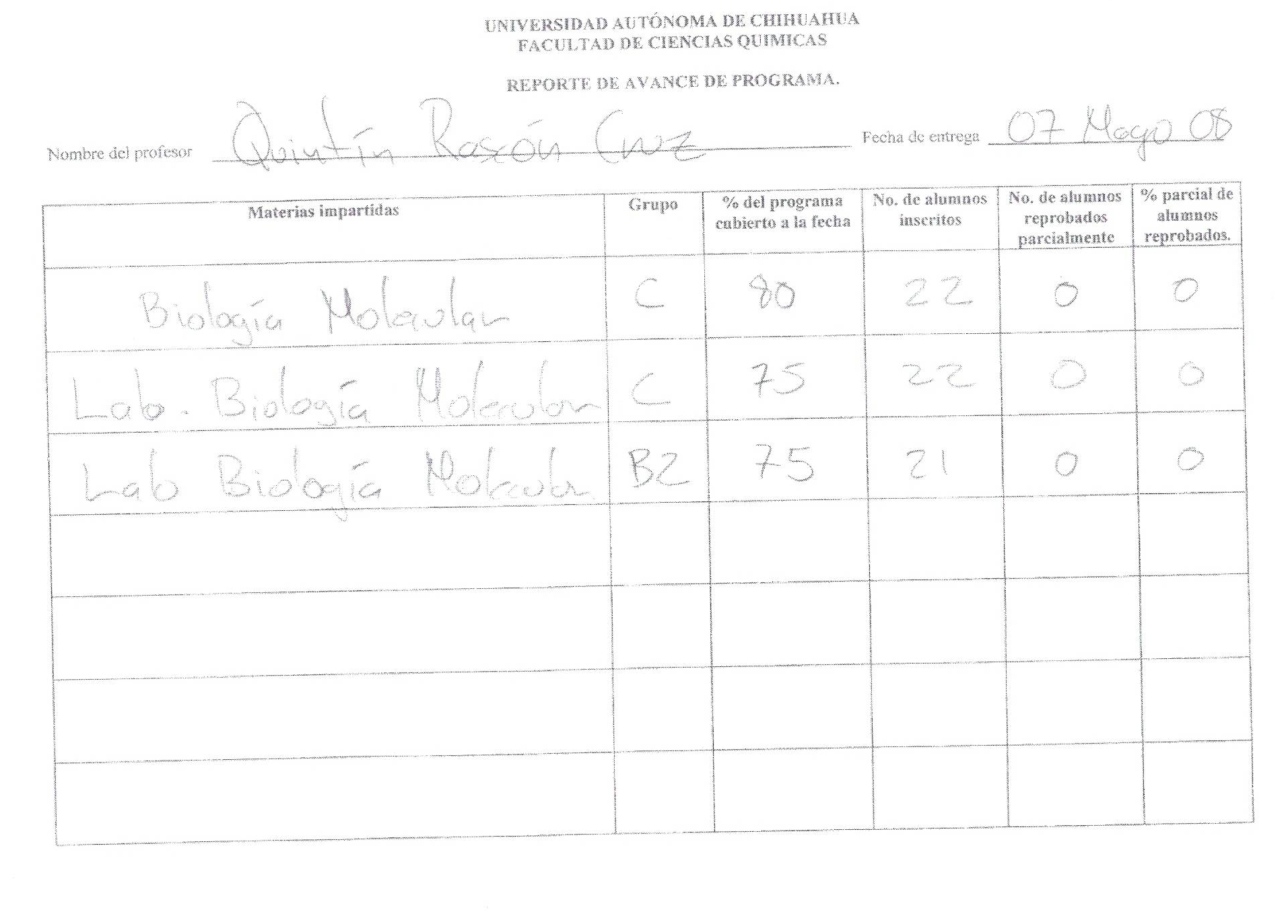

SIGIFREDO AREVALO GALLEGOS

